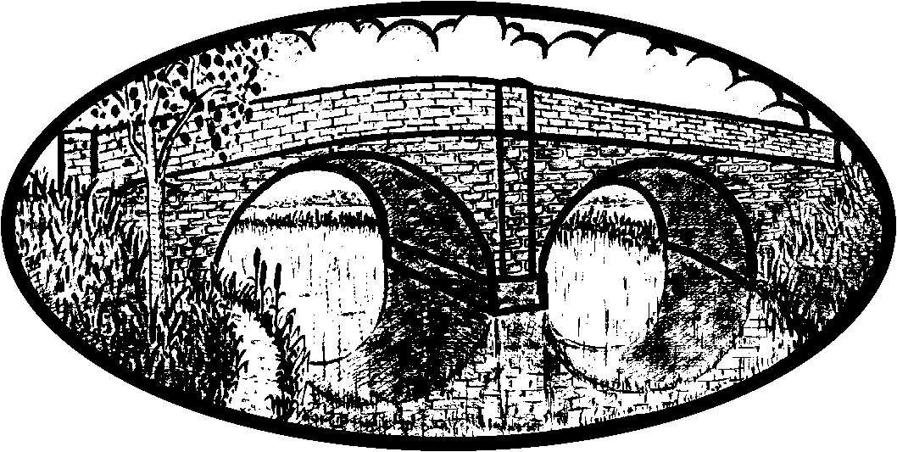

**Annual General Meeting**

Notice is hereby given that the 22nd Annual General Meeting of the Melton & Oakham Waterways Society will be held at Best Western Sysonby Knoll Hotel, Asfordby Road, Melton Mowbray, LE13 0HP on Saturday 2 November 2019, commencing at 10.30am.

The normal AGM business will be concluded with a short break followed by entertainment from the chairman’s special guests, after which light refreshments will be available and an opportunity to meet and talk to committee and other society members.

**AGENDA**

1. Apologies for Absence
2. Minutes of the 21st AGM held on Saturday 17 November 2018
3. Matters Arising from the Minutes
4. Report from the Chairman, Mick Clowes
5. Treasurer’s Report and Presentation of 2018/2019 Accounts
6. Election of Committee Members
7. Any Other Business / Open Discussion

***Break***

1. Special Guests – The Quorn Ukulele Orchestra

*Registered Charity No 1078752*

**Melton & Oakham**

**Waterways Society**

September 2019